Q1.
Dastan
Dastan is a two-player game in which each player takes turns to move one of their five pieces on a six-by-six square grid. Each player has one mirza (ruler) and four standard pieces. Each player has a kotla (fortress).
The winner is the player who has the highest score when the game ends. The game ends when a player manages to move their mirza into the square containing the opponent’s kotla or they capture the opponent’s mirza.
The starting position of the game is shown in Figure 1. Player one’s mirza piece is represented by 1, their other pieces by ! and their kotla by K. Player two’s mirza piece is represented by 2, their other pieces by " and their kotla by k. Row numbers are shown on the left-hand side and column numbers at the top.
Figure 1

 | 1 | 2 | 3 | 4 | 5 | 6
1 |  |  | K1
2 |  | ! | ! | ! | !
3
4
5 |  | '' | '' | '' | ''
6 |  |  |  | k2
Each player has a queue of five move options from which they can select the type of move they wish to make. On their turn, a player will make a selection from their queue of move options, choose one of their pieces to use with the move option and select the square to move to. This move is then made on the board. If the piece moved lands in the same square as one of the opponent’s pieces then the opponent’s piece is removed from the game.
The player can select any one of the first three move options from their queue to use; after use it is added to the rear of the queue.
Each move option has a name and details of how a piece can be moved. The move options are shown in Figure 2. The * represents the square currently occupied by the piece that is being moved. All of the move options are shown from the perspective of player two. Each X represents a square that the piece can be moved to.
Figure 2

Move option | Description
Ryott  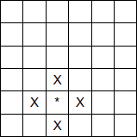 | The ryott (peasant) move option means a piece can move one square orthogonally from its current position.
Chowkidar  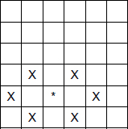 | The chowkidar (guard) move option means a piece can move either exactly two squares horizontally or one square diagonally from its current position.
Faujdar  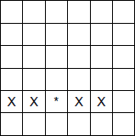 | The faujdar (fort keeper) move option means a piece can move either one or two squares horizontally from its current position.

Jazair  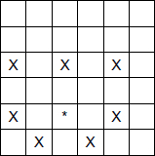 | The jazair (camel-mounted swivel gun) move option means a piece can move either two squares horizontally, two squares forward (either vertically or diagonally) or one square backwards diagonally from its current position.
Cuirassier  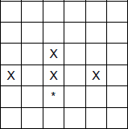 | The cuirassier (armoured cavalry with a musket) move option means a piece can move either one or two squares forward, or two squares horizontally followed by one square forward from its current position.
In the game, there is an offer that contains a move option. Before moving a piece, a player can choose to take the move option from the offer, replacing one of the move options in their queue with it. A new move option will then be generated for the offer.
Each player starts the game with a score of 100. Their score decreases when they:
• move a piece – the amount of the decrease is based on how near the front of the queue the chosen move option was
• take the move option from the offer – the amount of the decrease is based on how near the front of the queue the replaced move option was.
Their score increases if:
• they capture an opponent’s piece (by 1) or an opponent’s mirza (by 5)
• one of their pieces or their mirza is occupying the same square as a kotla (by 5 for their own kotla; by 1 for their opponent’s).
Figure 3 shows the first few turns of a sample game.
Figure 3

Start state | Description | New state
Board:  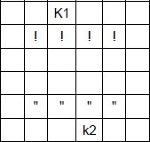  Player one’s turn  Player one queue:  1. ryott  2. chowkidar  3. cuirassier  4. faujdar  5. jazair  Offer: jazair  Player one score: 100 | It is player one’s turn and they choose move option 3 (cuirassier) from the queue, the piece in row 2 column 2 and decide to move it forward 2 squares.  Their score decreases by 7 as they chose the third move option in their queue.  Their score increases by 5 as their mirza is in the square containing their kotla. | Board:  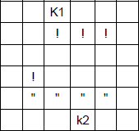  Player one queue:  1. ryott  2. chowkidar  3. faujdar  4. jazair  5. cuirassier  Offer: jazair  Player one score: 98

Board:  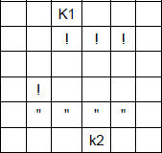  Player two’s turn  Player two queue:  1. ryott  2. chowkidar  3. jazair  4. faujdar  5. cuirassier  Offer: jazair  Player two score: 100 | Player two chooses move option 1 (ryott), the piece in row 5 column 2 and decides to move it one square forwards. The square the piece is moving to contains one of the opponent’s pieces so that piece is captured.  Player two chose the first item in their queue, so their score decreases by 1 but is then increased by 1 for capturing a piece.  Their score increases by 5 as their mirza is in the square containing their kotla. | Board:  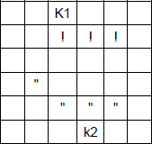  Player two queue:  1. chowkidar  2. jazair  3. faujdar  4. cuirassier  5. ryott  Offer: jazair  Player two score: 105

Board:  Player one’s turn  Player one queue:  1. ryott  2. chowkidar  3. faujdar  4. jazair  5. cuirassier  Offer: jazair  Player one score: 98 | Player one decides to take the move option in the offer and replaces their ryott with a jazair.  This reduces their score by 8.  The offer is replenished by a randomly selected move option.  Taking the move option from the offer does not count as a move; their score is not increased even though their kotla is occupied.  It is still player one’s turn. | Board:  Player one’s turn  Player one queue:  1. jazair  2. chowkidar  3. faujdar  4. jazair  5. cuirassier  Offer: cuirassier  Player one score: 90

Board:  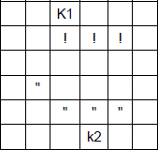  Player one’s turn  Player one queue:  1. jazair  2. chowkidar  3. faujdar  4. jazair  5. cuirassier  Offer: cuirassier  Player one score: 90 | Player one chooses move option 1 (jazair, the move option they have just taken from the offer), the piece in row 2 column 4 and decides to move it forward 2 right 2. This captures one of the opponent’s pieces.  Player one chose the first item in their queue, so their score decreases by 1 but is then increased by 1 for capturing a piece.  Their score increases by 5 as their mirza is in the square containing their kotla.  It is now player two’s turn. | Board:  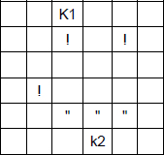  Player one queue:  1. chowkidar  2. faujdar  3. jazair  4. cuirassier  5. jazair  Offer: cuirassier  Player one score: 95

Board:  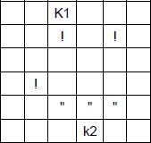  Player two’s turn  Player two queue:  1. chowkidar  2. jazair  3. faujdar  4. cuirassier  5. ryott  Offer: cuirassier  Player two score: 105 | Player two chooses move option 1 (chowkidar), the piece in row 6 column 4 (their mirza) and decides to move it right 2.  Player two chose the first item in their queue, so their score decreases by 1.  They no longer have a piece in the square containing their kotla, so they do not get any points for occupying that square.  It is now player one’s turn. | Board:  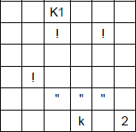  Player two queue:  1. jazair  2. faujdar  3. cuirassier  4. ryott  5. chowkidar  Offer: cuirassier  Player two score: 104

